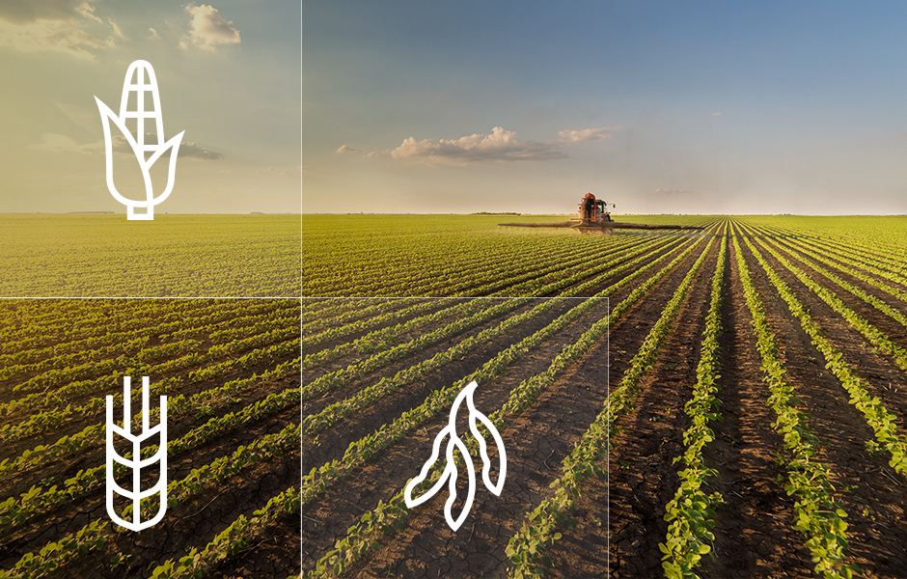

krishna praveen kumar | INT404 | April 5, 2020

CROP PREDICTION

AI BASED CROP MONITORING SYSTEM

* CROP PREDICTION USING ARTIFICIAL INTELLIGENCE.
* AT FIRST THE WORLD POPULATION IS EXPECTED TO GROW ACCORDING TO THE SURVEY TAKEN BY THE AGRICULTURE ORGANIZATION.
* WITH ARTIFICIAL INTELLIGENCE TOOLS WE CAN MONITOR CROP
* LAND SUITABILITY ANALYSIS IS A MANDATORY FOR CROP CULTIVATION

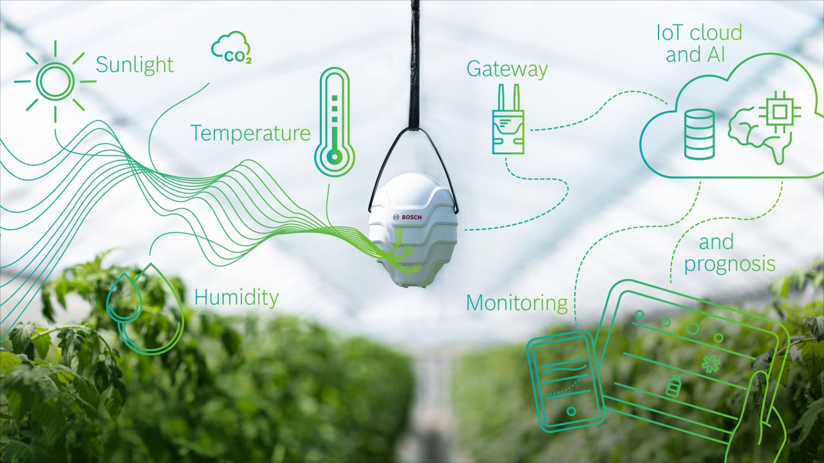

* FOR PREDICTING CROP, WE NEDD TO KNOW ABOUT SUNLIGHT, TEMPERATURE, HUMIDITY, Ph AND IOT CLOUD AND AI.
* THESE ARE THE KEY FACTORS FOR PREDICTING CROP.
* IN PRESENT AND FUTURE ARTIFICIAL INTELLIGENCE TECHNOLOGY IS VERY IMPORTANT.
* IT’S VERY DIFFICULT TO PREDICT EVERYTHING FOR FORMER BUT USING AI WE CAN EASILY PREDICT.

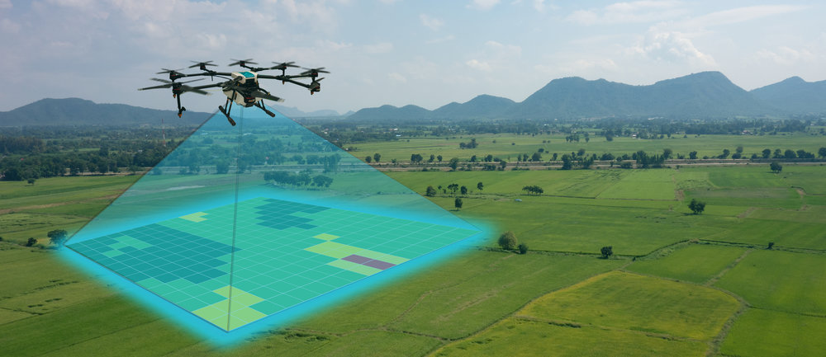

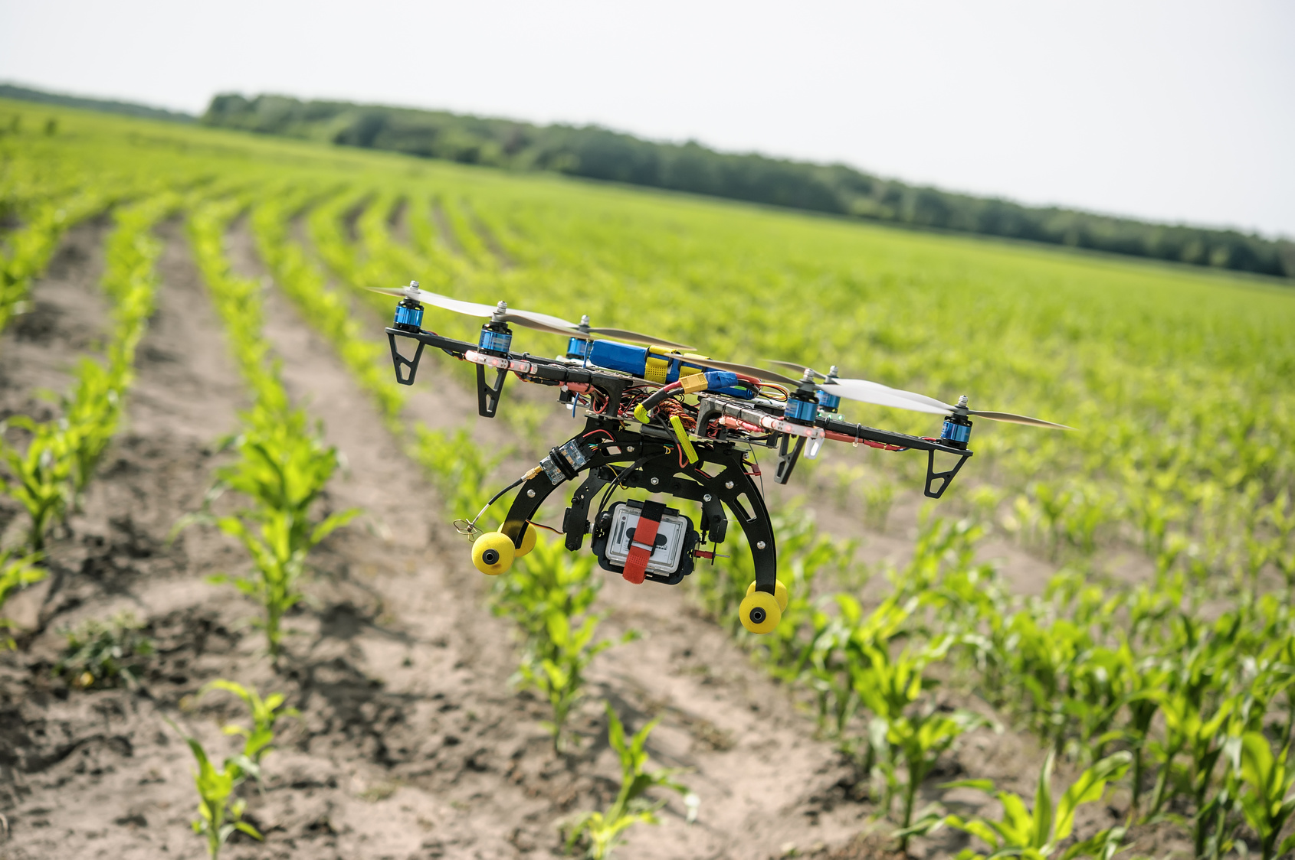SOURCE CODE RESULT:

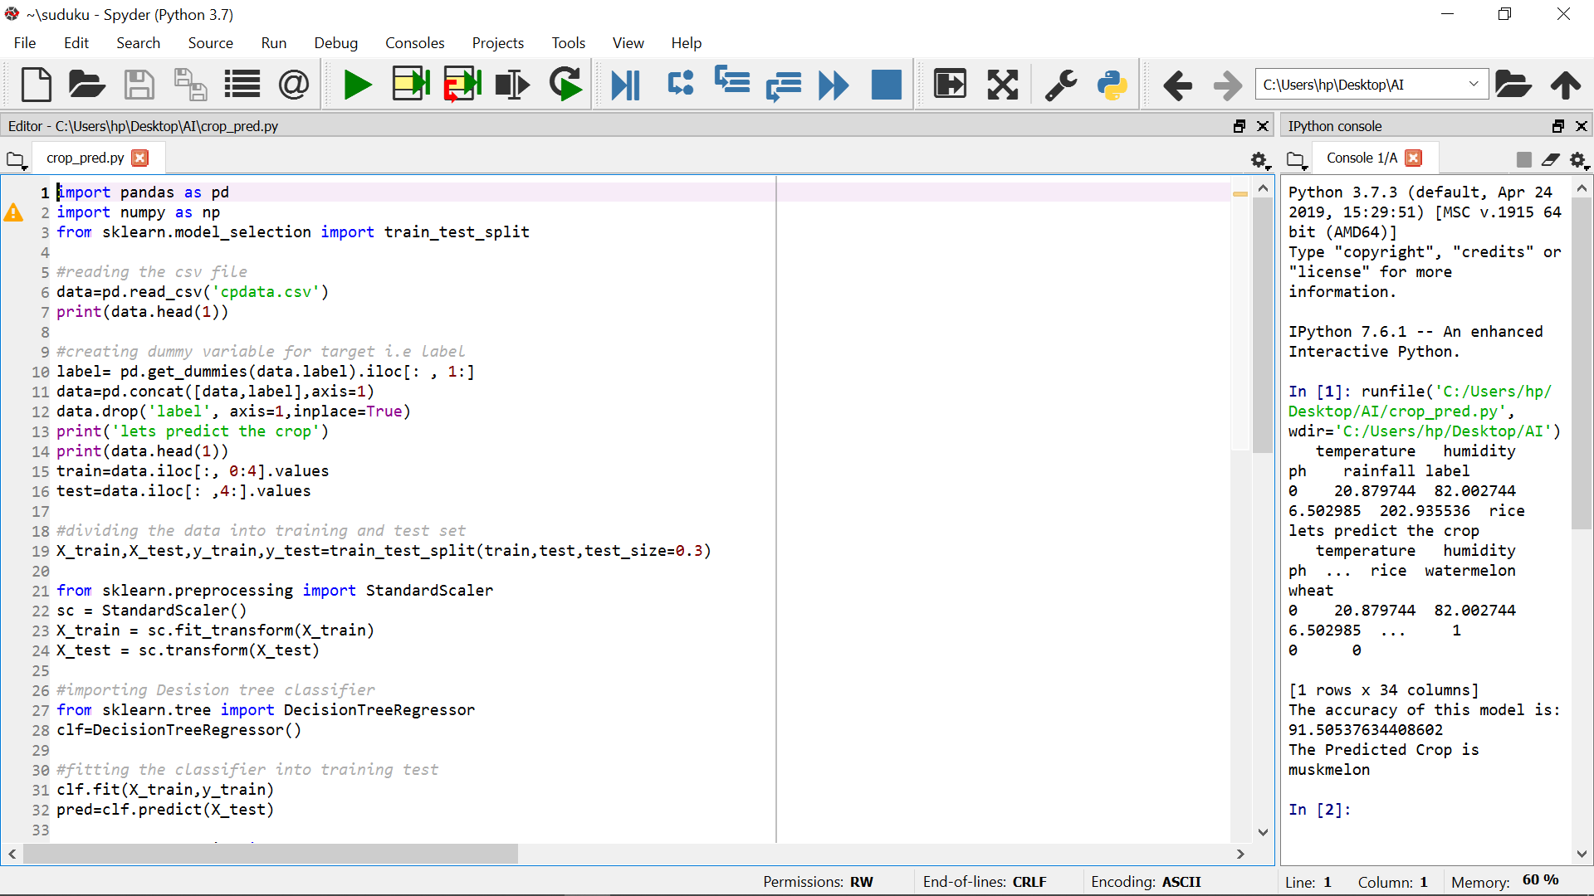

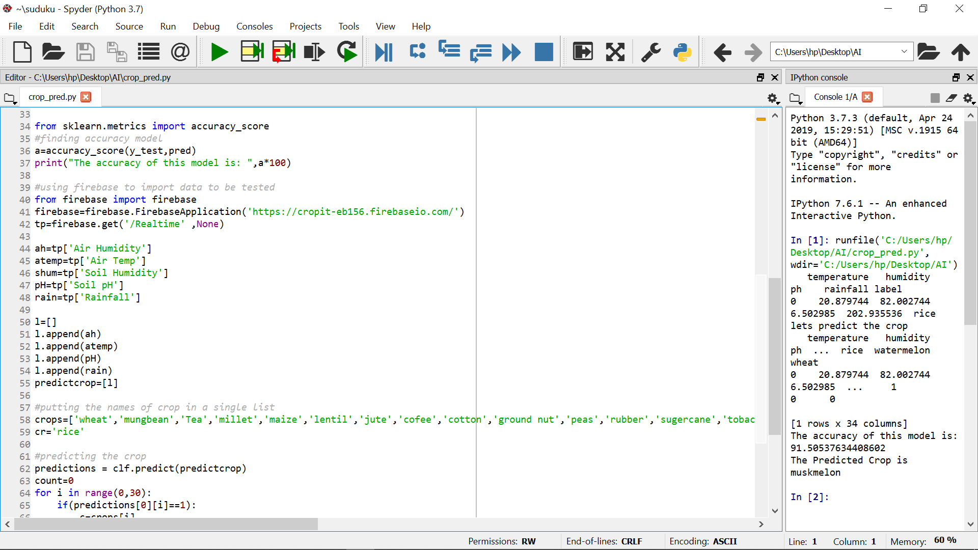

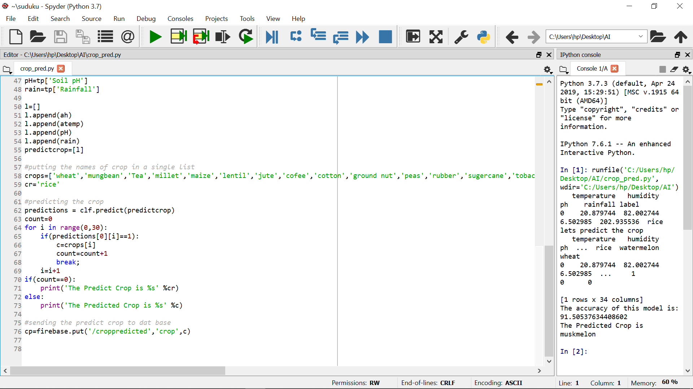

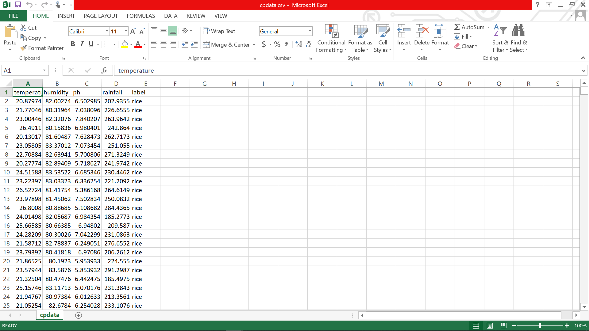

OUTPUT:

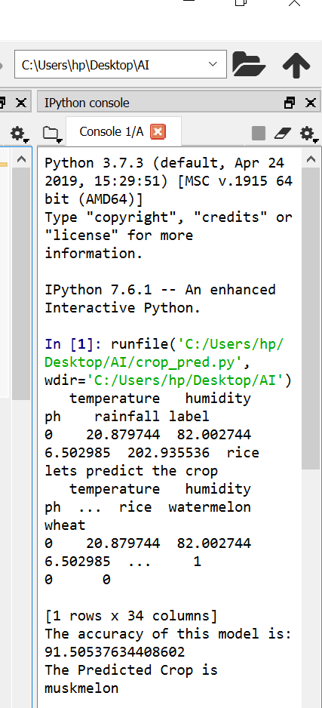

SUBMITTED BY:

|  |  |  |  |
| --- | --- | --- | --- |
|  |  |  |  |
| SECTION | STUDENT NAME | ROLL NO | REG.NO |
| K18NZ | G. K. PRAVEEN KUMAR | 59 | 11803789 |
| K18NZ | ANSHU UTTAM | 58 | 11804439 |
| K18NZ | M. NIKHIL | 60 | 11805204 |

SUBMITTED TO:

JASLEEN KAUR MAM

THANK

YOU